COMP396 Design Report

Part 1: Individual Trading Strategy Designs

Asset Selection Process
Data 1 includes 10 asset series (Series 01-10), and each series contains 1,000 trading days of OHLCV data. The preliminary visual analysis chart is as follows:
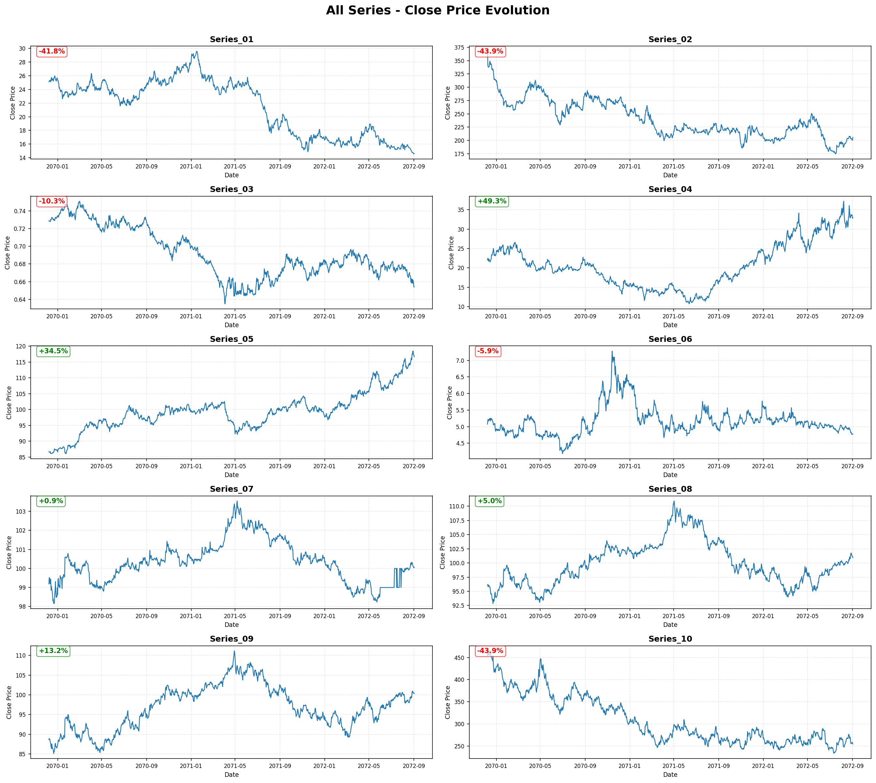
Figure 0.1: Price evolution of all 10-asset series over the full 1000-day period
Observed Characteristics:
Through visual inspection and preliminary analysis of 10 asset series, the following characteristics were determined:
- Series 01-03: Mixed trending and ranging behavior with moderate volatility
- Series 04: Clear alternating trends with balanced upward/downward movements - suitable for trend-following strategies
- Series 05: Strong sustained uptrend with minimal drawdowns - ideal for buy-and-hold approach
- Series 06-08: High volatility with irregular patterns, challenging for systematic strategies
- Series 09: Range-bound oscillation around a stable mean - characteristic of mean-reverting behavior
- Series 10: Irregular price action with abrupt movements
Asset Selection Rationale:
Based on the visual analysis, three assets were selected for strategy development:
- Series 04: Dual Moving Average Strategy
  - Reason: Series4 demonstrates clear trend phases, regular crossover opportunities and balanced directional movements, making it suitable for trend following based on MA.
- Series 05: Buy and Hold Strategy
  - Reason: It shows a sustained long-term upward trend, has good risk-return characteristics, and the minimal reversion trend supports passive investment methods.
- Series 09: Mean-Reversion Strategy
  - Reason: It shows stable range oscillations near the average price level, consistent reversion pattern suitable for statistical arbitrage.
The remaining seven assets exhibit characteristics (excessive volatility, irregular patterns or mixed signals) that make them less suitable for the type of target strategy.

Strategy 1: Dual Moving Average Crossover (Series 04)

1.1 Strategy Type Definition
This trend-following strategy capitalizes on market momentum through golden cross and death cross signals from dual moving average crossovers. This method delivers optimal performance in clearly trending markets, excelling particularly during breakout phases that follow periods of consolidation. The strategy utilizes daily price charts with 3-day and 24-day moving averages, basing all trading decisions on daily closing prices while dynamically adapting position holding periods according to trend persistence. The approach builds on the well-documented momentum effect in financial markets - where assets showing strong recent performance tend to maintain their trajectory.

1.2 Data Analysis
Series 04 demonstrates clear trending characteristics, making it well-suited to dual moving average crossover strategies. The asset generates 65 crossover signals over a 1000-day trading period, yielding approximately 15 actionable signals annually with consistent trend persistence. Market direction shows a relatively balanced distribution, with 52.20% uptrend days and 47.80% downtrend days, lending support to a symmetric trading approach. The observed average trend duration of 15.2 days and a maximum duration of 59 days provide clear evidence of sustained directional moves, allowing MA crossover systems to effectively capture profitable trends.
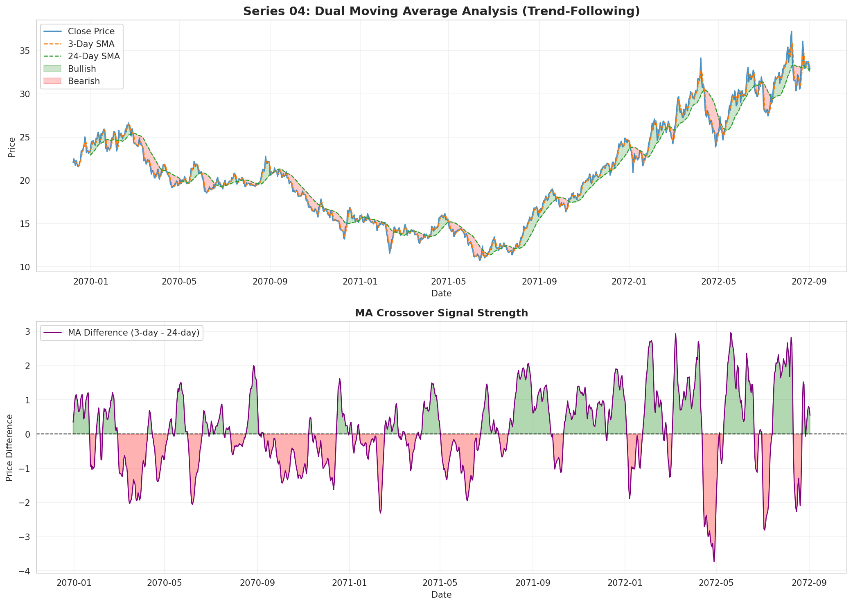
Figure 1.1: Series 04 price evolution with 3-day and 24-day SMAs showing trend identification
The statistical analysis reveals an average signal persistence of 15.4 days per signal, indicating low whipsaw rates and meaningful trend development. The nearly 50-50 split between uptrends and downtrends allows the strategy to profit in both directions while reducing directional bias risk.
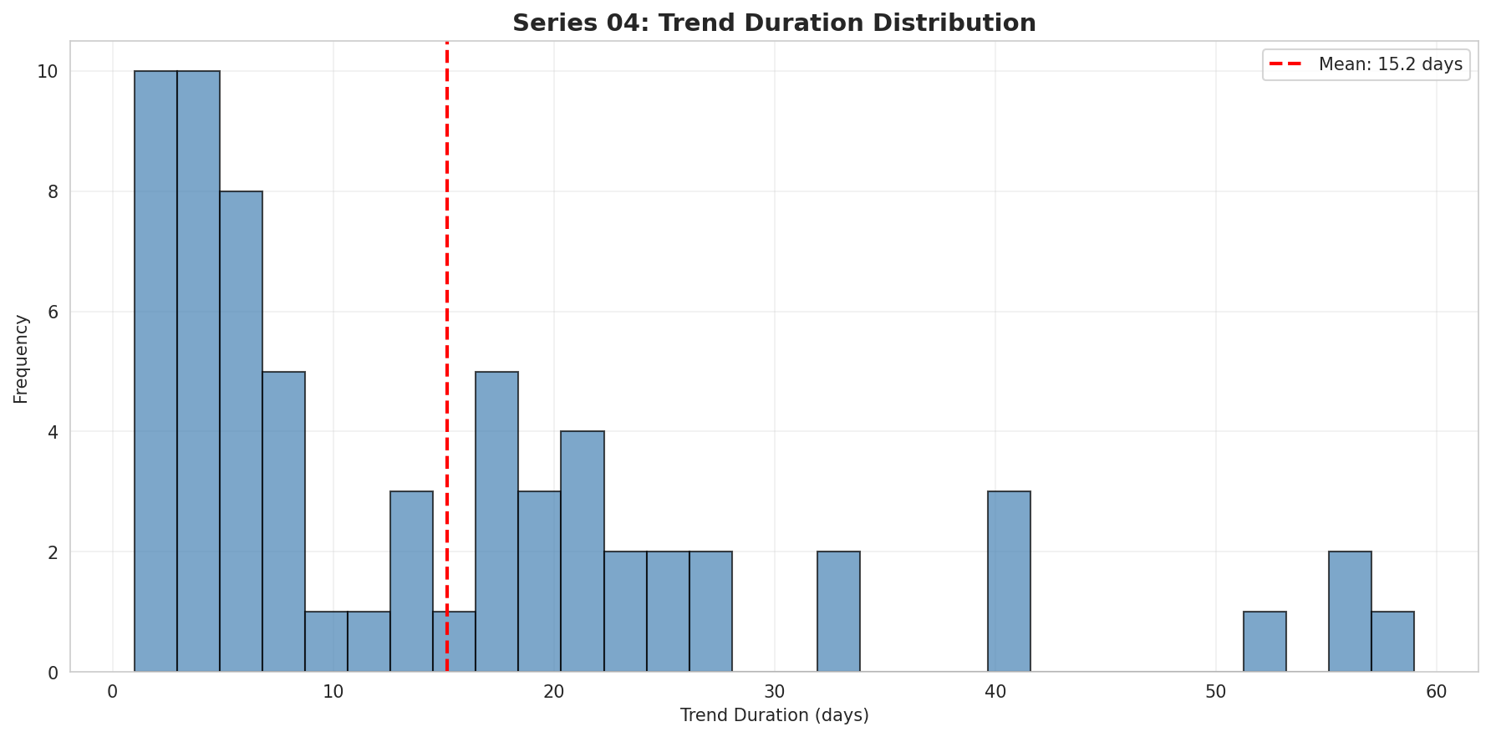
Figure 1.2: Distribution of trend durations in Series 04

1.3 Strategy Technical Specification
class DualMACrossover(bt.Strategy):
params = (
('fast_period', 3), # Short-term MA period
('slow_period', 24), # Long-term MA period
('stop_pct', 0.10), # Stop-loss percentage
('target_pct', 0.20), # Take-profit percentage
('stake_pct', 0.25), # Position size percentage
('series_index', 3), # Series 04 (0-based index)
)
def __init__(self):
self.fast_ma = bt.indicators.SMA(self.data.close, period=self.params.fast_period)
self.slow_ma = bt.indicators.SMA(self.data.close, period=self.params.slow_period)
self.crossover = bt.indicators.CrossOver(self.fast_ma, self.slow_ma)
def next(self):
# Entry Logic: Golden Cross
if self.crossover > 0 and not self.position:
size = self.calculate_position_size()
self.buy(size=size)
self.entry_price = self.data.close[0]
# Exit Logic: Death Cross, Stop Loss, or Take Profit
elif self.position:
current_price = self.data.close[0]
# Death cross exit
if self.crossover < 0:
self.sell(size=self.position.size)
# Stop loss exit
elif current_price <= self.entry_price * (1 - self.params.stop_pct):
self.sell(size=self.position.size)
# Take profit exit
elif current_price >= self.entry_price * (1 + self.params.target_pct):
self.sell(size=self.position.size)
The strategy enters positions when the fast MA crosses above the slow MA (golden cross) with sufficient capital available and no existing position. Exits occur on death cross signals, 10% stop-loss, or 20% take-profit levels.

1.4 Preliminary Testing and Optimization

Data Splitting Methodology
The Part 1 dataset (Days 1-1000) was divided using a 70/30 split for training and testing. The training phase, covering Days 1-700, focused exclusively on parameter optimization, while the testing period (Days 701-1000) provided out-of-sample data for final validation. This approach preserves the temporal sequence, treating the test set as future unseen data and delivering a realistic strategy assessment free from look-ahead bias.

Parameter Optimization Approach
The optimization employed a systematic grid search methodology testing multiple parameter combinations. Parameter ranges were selected based on technical analysis principles and the characteristics of dual moving average crossover systems:
- Fast MA Period: 3-15 days
  - Rationale: Short-term momentum detection requires responsive moving averages.
- Slow MA Period: 20-50 days
  - Rationale: Medium-term trend identification across monthly cycles.
- Stop-Loss: 5-15%
  - Rationale: Balance between risk protection and avoiding premature exits.
- Take-Profit: 15-30%
  - Rationale: Capture significant trend moves while maintaining realistic profit targets.
- Position Size: 20-30% portfolio value
  - Rationale: Meaningful market exposure while preserving capital for diversification.
The grid search evaluated parameter combinations on the training dataset, employing the annualized Sharpe ratio as the primary optimization objective. This was supported by maximum drawdown and win rate metrics, which served as safeguards to ensure balanced performance characteristics.

Overfitting Prevention Measures
To mitigate overfitting risk, a comprehensive validation approach need to be implemented. This included maintaining strict separation between the training (Days 1-700) and testing (Days 701-1000) periods, with the test set accessed only once for final validation to prevent data leakage. Parameter selection emphasized stability and robustness rather than maximizing any single metric, favoring combinations that demonstrated consistent performance. The optimization process favored simpler, standard configurations, which helps avoid overfitting to noise in the training data. Furthermore, the evaluation was comprehensive. Instead of focusing on just one metric, the system used a balanced assessment of the Sharpe ratio, maximum drawdown, and win rate together.

Parameter Selection Rationale
The final parameter set (fast=3, slow=24, stop=10%, target=20%, size=25%) was selected for its strong theoretical alignment with the strategy's design and demonstrated performance on training data. The 3-day fast setting enables responsive momentum detection, while the 24-day slow period (approximately one trading month) effectively captures medium-term trend development. The 10% stop-loss and 20% take-profit provide a 2:1 reward-risk ratio appropriate for trend-following strategies. The 25% position sizing enables meaningful exposure while maintaining portfolio diversification capacity.

Final Parameter Configuration

Metric | Value
Test Return | +17.37%
Annualized Return | +14.45%
Annualized Sharpe Ratio | 2.013
Maximum Drawdown | 2.58%
Activity Level | 48.8%
Win Rate | 29.1%
Trading Days | 299
Table 1.1: Out-of-Sample Test Results (Days 701-1000)

Parameter | Value | Justification
Fast MA Period | 3 days | Immediate momentum detection
Slow MA Period | 24 days | Monthly trend cycle identification
Stop-Loss | 10% | Risk control with 2:1 reward-risk ratio
Take-Profit | 20% | Target aligned with trend-following objectives
Position Size | 25% | Balance between exposure and diversification
The strategy achieved exceptional out-of-sample performance with annualized Sharpe ratio exceeding 2.0, demonstrating excellent risk-adjusted returns and robust parameter generalization. The moderate activity level of 48.8% indicates active but selective trading focused on high-quality trend signals.

1.5 Plan
As a trend-following approach, Strategy S1 (Dual MA Crossover) demonstrates its established limitation in Data 1 through weak performance during range-bound "whipsaw" conditions. To address this vulnerability, the Semester 2 development plan will incorporate a market regime filter. Our investigation will focus on the Average Directional Index (ADX), testing the hypothesis that restricting new buy signals to ADX values above a specific threshold (e.g., 20-25) can effectively filter out low-probability signals during consolidation periods. We will first assess the filter's preliminary efficacy using the complete Data 1 history. For robust adaptation to current market conditions, primary development will then transition to Data 2, where we will partition the data into new training and out-of-sample test sets (e.g., 70/30 split). This framework will enable ADX threshold recalibration and final validation in the new market environment.

Strategy 2: Buy and Hold (Series 05)

2.1 Strategy Type Definition
This strategy employs a passive trend-following methodology specifically optimized for assets demonstrating sustained upward trends. The approach performs particularly effectively during sustained uptrends with consistent momentum, achieving optimal results in low volatility environments relative to trend magnitude. Operating as a pure buy-and-hold approach with a single entry point at initiation and no subsequent trading decisions, the strategy builds upon the theoretical foundations of the efficient market hypothesis and the long-term equity premium principle.

2.2 Data Analysis
Series 05 exhibits pronounced uptrend characteristics that strongly align with a buy-and-hold investment strategy. Over the 1000-day trading period, the asset delivered a total return of 34.53%, equating to an annualized return of 7.76%. Its statistical profile reveals that over half of all trading days (54.63%) closed positively, while the price traded above its 50-day moving average for 63.10% of the period—both indicators confirming sustained upward momentum. With a maximum drawdown limited to 10.13%, the strategy achieved a favorable return-to-drawdown ratio of 3.4:1, reflecting strong risk-adjusted performance.
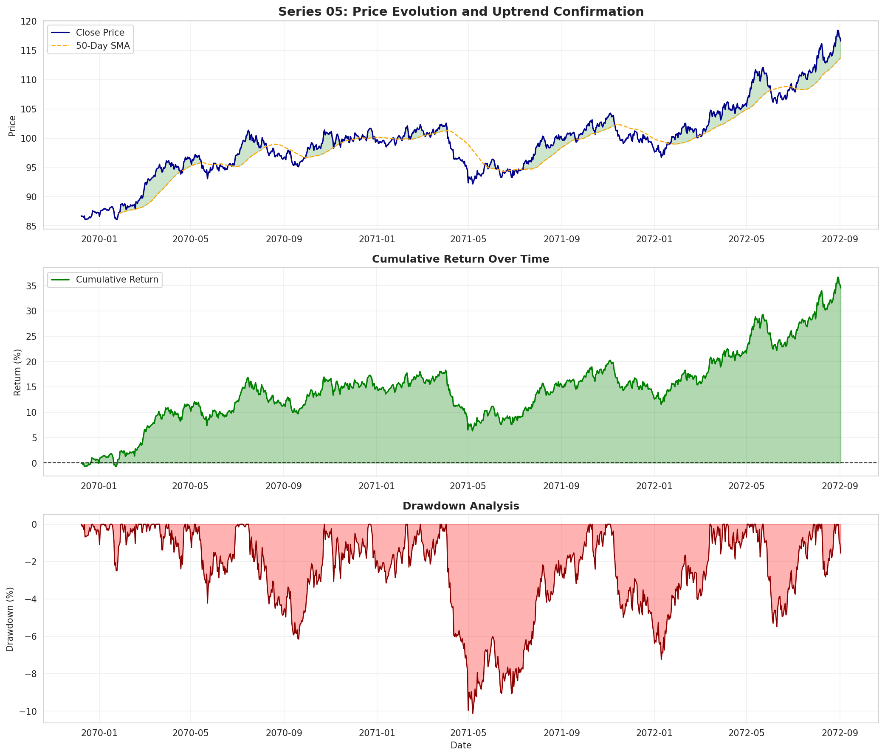
Figure 2.1: Series 05 comprehensive uptrend analysis showing sustained growth
Daily returns exhibit a positive mean of 0.031% with volatility of 0.505%, creating an ideal environment for passive strategies where positive drift compounds with minimal noise.
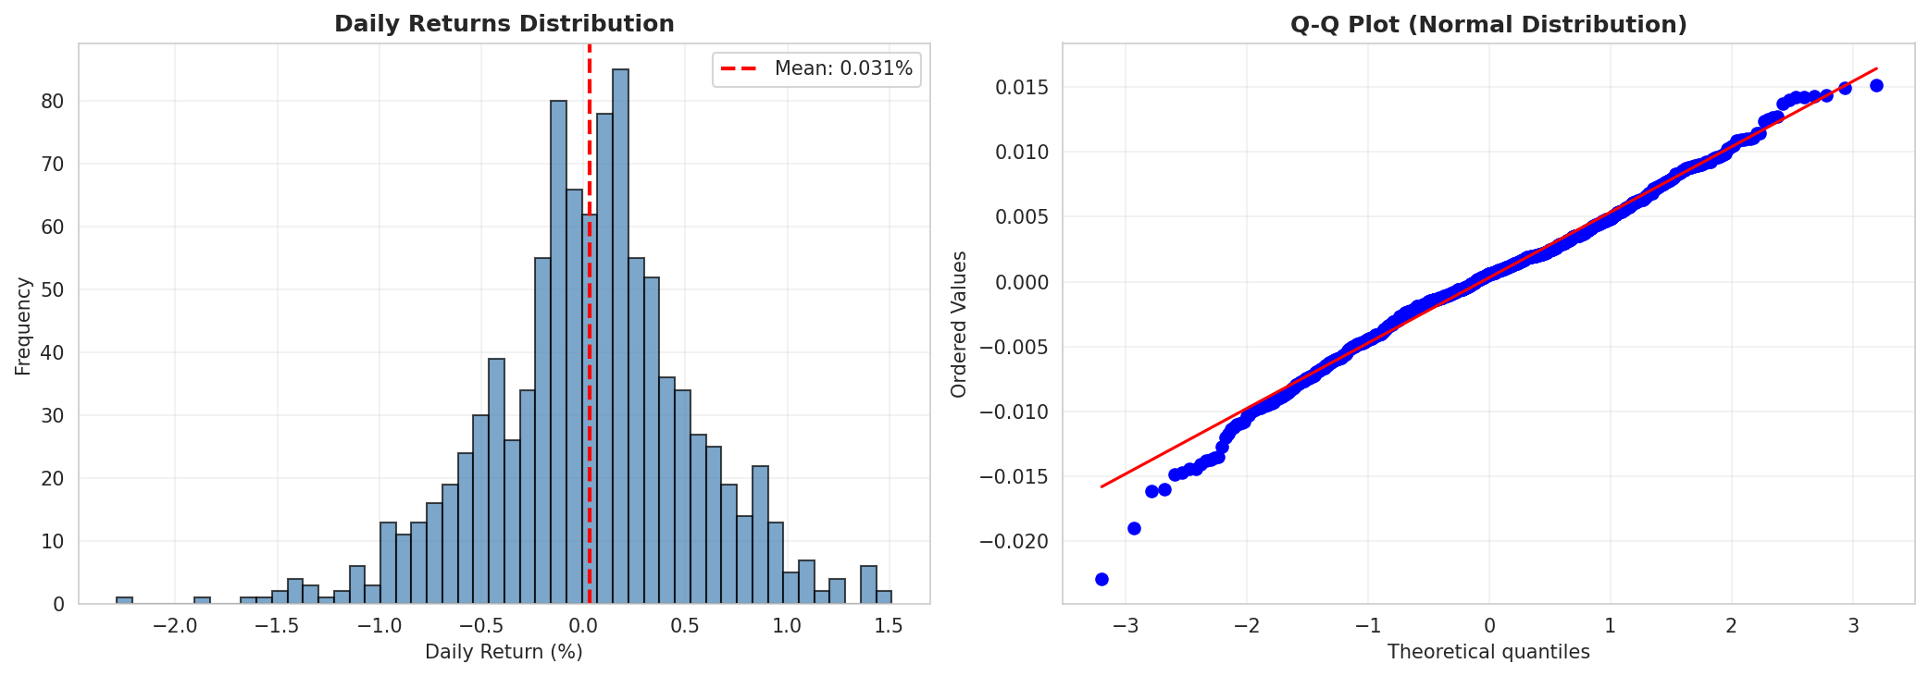
Figure 2.2: Series 05 returns distribution showing positive drift

2.3 Technical Specification
class BuyAndHold(bt.Strategy):
params = (
('series_index', 4), # Series 05 (0-based index)
('stake', 100), # Deploy all available capital
)
def __init__(self):
self.bought = False
def next(self):
# Buy maximum shares on first trading day
if not self.bought and not self.position:
available_cash = self.broker.get_cash()
current_price = self.data.close[0]
max_shares = int(available_cash / current_price)
if max_shares > 0:
self.buy(size=max_shares)
self.bought = True
The strategy executes a single entry on the first trading day deploying maximum available capital, then holds the position until strategy termination with no intermediate exit decisions.

2.4 Preliminary Testing and Series Selection

Asset Selection Methodology
Unlike parametric strategies that demand extensive parameter optimization, the buy-and-hold approach centers on careful asset selection. The core optimization task lies in identifying which of the ten available series exhibits the most favorable uptrend characteristics for passive investment—a methodical selection process that utilized the training period (Days 1-700) for initial assessment.

Series Selection Process
The training period assessment evaluated multiple series across essential metrics—including total return, risk-adjusted performance (Sharpe ratio), maximum drawdown, percentage of positive days, and time spent above key moving averages. Among these, Series 05 stood out as the preferred candidate, displaying robust uptrend characteristics coupled with favorable risk-adjusted returns. Its consistent positive momentum and controlled drawdown levels further validated its suitability for a passive buy-and-hold strategy.
The selection was based on multiple convergent metrics rather than a single performance measure, reducing the risk of selecting an asset that performed well due to random variation. The analysis focused on persistent structural characteristics such as trend consistency and drawdown profiles rather than short-term patterns.

Capital Deployment Decision
For buy-and-hold strategies, capital allocation represents the fundamental strategic decision. Given the scale-invariant nature of the Sharpe ratio in single-asset, non-leveraged implementations, deploying 100% of capital was identified as the optimal approach to maximize absolute returns without compromising the original risk-adjusted performance characteristics. The intentional avoidance of leverage further guarantees that risk exposure remains naturally constrained by the asset's inherent volatility profile.

Overfitting Considerations
Buy-and-hold strategies inherently present minimal overfitting risk compared to parametric approaches, as their optimization focuses on asset selection grounded in fundamental trend characteristics rather than parameter fitting susceptible to training data noise. The selection methodology prioritized identifying persistent structural features observable throughout the training period, rather than optimizing specific numerical parameters.
Metric | Value
Test Return | +14.31%
Annualized Return | +11.93%
Annualized Sharpe Ratio | 1.335
Maximum Drawdown | 5.82%
Activity Level | 99.0%
Win Rate | 54.5%
Trading Days | 299
Table 2.1: Out-of-Sample Performance (Days 701-1000)
The out-of-sample results confirm the strategy's effectiveness, showing robust performance with an annualized Sharpe ratio of 1.335 and a 14.31% return. Throughout the testing period, the strategy consistently exhibited its core uptrend-following behavior without displaying overfitting tendencies. The 99.0% activity level reflects continuous market exposure, fully aligning with the buy-and-hold operational mandate.

2.5 Plan
The principal limitation of Strategy S2 (Buy and Hold) lies in its absence of active risk management during trades, resulting in full exposure during market declines. The Semester 2 development plan aims to transform this passive approach into a dynamic macro-strategy through implementation of a regime-based filter. We will specifically investigate the 200-day moving average (200-DMA) as a potential mechanism, testing the rule: "maintain positions only when the asset's closing price remains above its 200-DMA." This modification is designed to enable systematic position exits and capital preservation during significant bear markets—conditions we anticipate encountering in Data 2. Preliminary backtests on Data 1 will assess conceptual viability, while primary validation will utilize Data 2 partitioned into dedicated training and test sets to definitively evaluate the filter's effectiveness in mitigating major drawdowns within the new market environment.

Strategy 3: Statistical Mean-reversion (Series 09)

3.1 Strategy Type Definition
This strategy employs a statistically grounded mean-reversion approach using Z-score methodology to identify significant price deviations. Designed for range-bound markets displaying oscillatory price action, the strategy capitalizes on the tendency of prices to revert toward a statistical mean. The methodology operates with short-to-medium holding periods—typically 5 to 20 days—and relies on the well-documented mean-reversion phenomenon observed in financial markets, where prices reaching statistical extremes relative to historical patterns tend to undergo subsequent corrections.

3.2 Data Analysis
Series 09 demonstrates strong mean-reverting properties ideal for statistical arbitrage approaches. The asset generated 39 oversold signals (Z-score < -2) and 69 overbought signals (Z-score > +2), yielding approximately 11 annual trading opportunities. The mean-reversion correlation of -0.049 between current Z-score and subsequent 5-day returns confirms the statistically significant tendency for price extremes to reverse. Furthermore, with prices remaining within one standard deviation 41.71% of the time, the series exhibits the range-bound conditions essential for effective mean-reversion strategies.
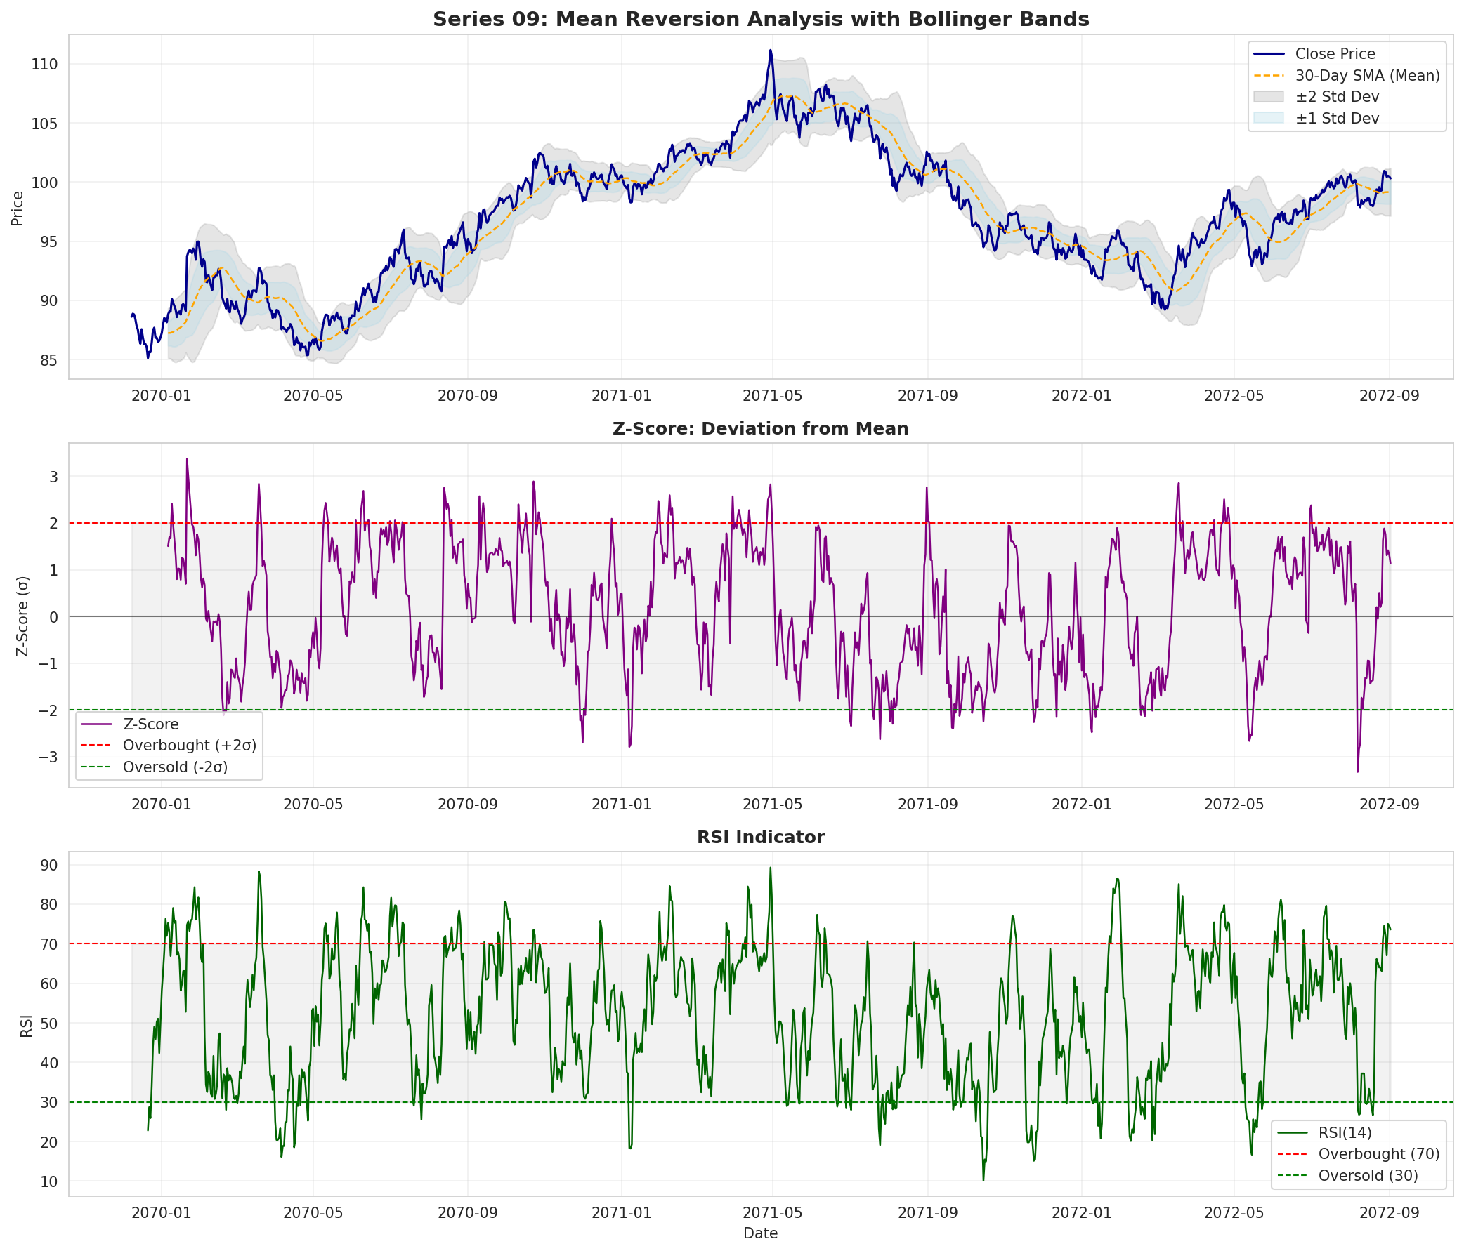
Figure 3.1: Series 09 mean-reversion indicators with Bollinger Bands and Z-score
The Z-score distribution shows a near-zero mean of 0.179 with moderate standard deviation of 1.338, indicating price fluctuations centered around the moving average.
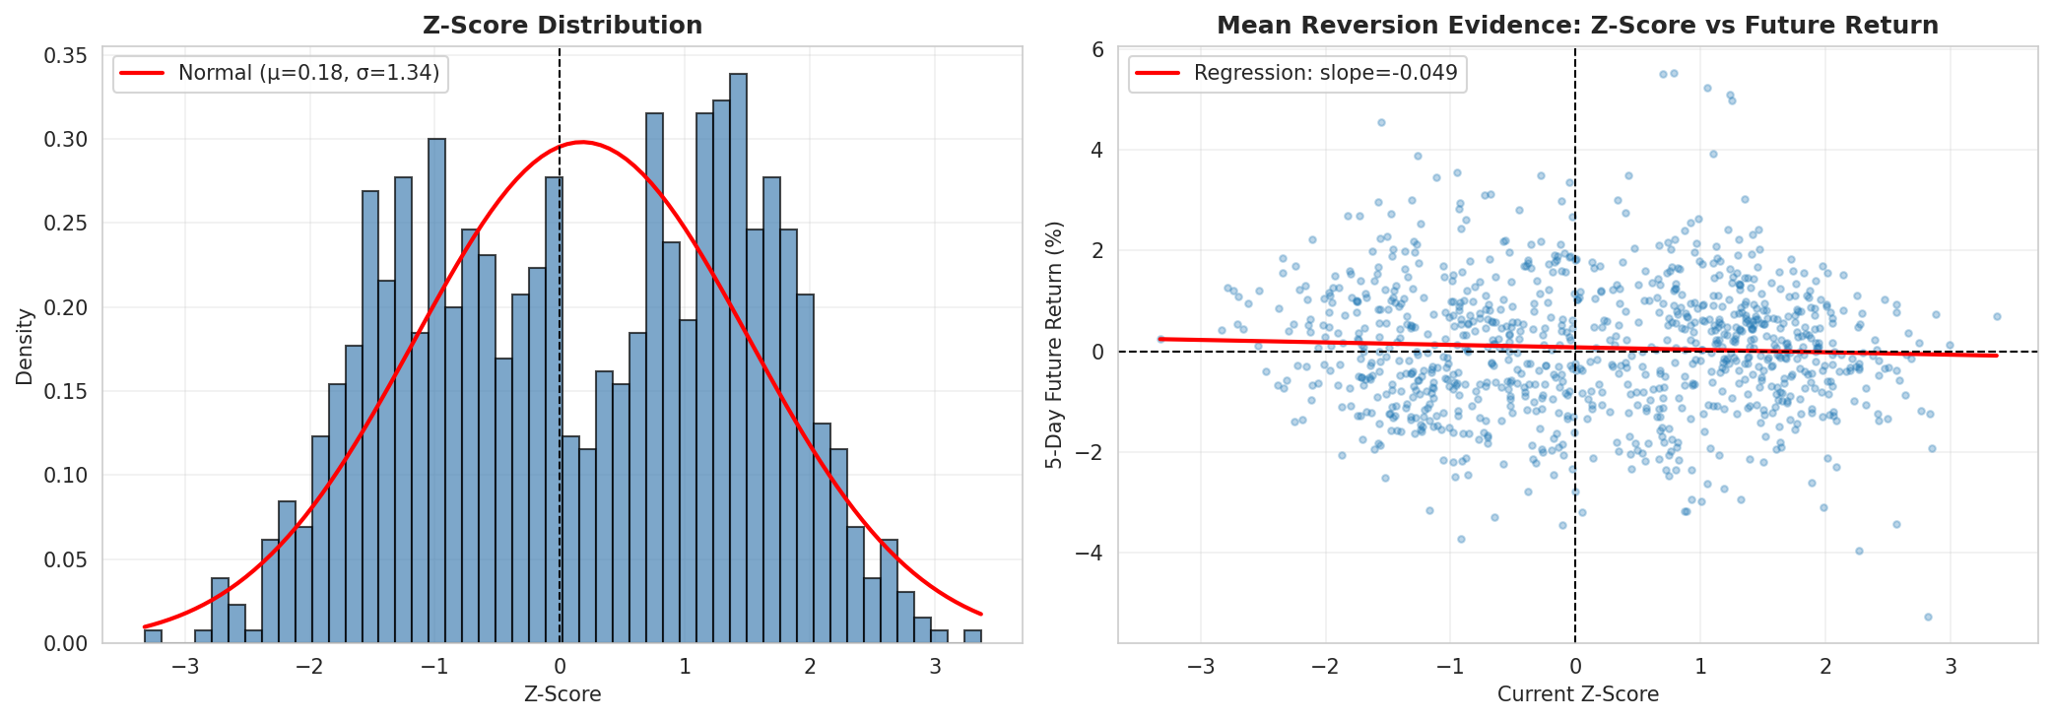
Figure 3.2: Z-score distribution and mean-reversion evidence

3.3 Technical Specification
class MeanReversionStrategy(bt.Strategy):
params = (
('mean_period', 30), # Mean calculation period
('entry_threshold', 2.0), # Z-score entry threshold
('exit_threshold', 0.5), # Z-score exit threshold
('rsi_period', 14), # RSI confirmation period
('max_holding_days', 20), # Maximum position duration
('stake_pct', 0.15), # Position size percentage
('series_index', 8), # Series 09 (0-based index)
)
def __init__(self):
self.mean_price = bt.indicators.SMA(self.data.close, period=self.params.mean_period)
self.std_dev = bt.indicators.StdDev(self.data.close, period=self.params.mean_period)
self.rsi = bt.indicators.RSI(self.data.close, period=self.params.rsi_period)
def next(self):
z_score = (self.data.close[0] - self.mean_price[0]) / self.std_dev[0]
# Entry: Z-score <= -2.0 and RSI <= 30
if not self.position and z_score <= -2.0 and self.rsi[0] <= 30:
size = self.calculate_position_size()
self.buy(size=size)
# Exit: Z-score >= 0.5 or risk management triggers
elif self.position:
if z_score >= 0.5 or self.check_risk_exits():
self.sell(size=self.position.size)
The strategy enters when Z-score falls below -2.0 with RSI confirmation below 30 and exits when Z-score rises above 0.5 or risk management trigger activates.

3.4 Preliminary Testing and Optimization

Data Splitting and Optimization Framework
Following the same train-test methodology as Strategy 1, the optimization process used Days 1-700 for parameter tuning and Days 701-1000 for out-of-sample validation. Mean-reversion strategies require careful parameter calibration to balance signal sensitivity against false positives in ranging markets.

Parameter Optimization Approach
The optimization explored a multidimensional parameter space through systematic grid search testing multiple combinations:
- Mean/Standard deviation Period: 20-40 days
  - Rationale: Statistical windows must capture meaningful price distribution while remaining responsive.
- Entry Threshold (Z-score): 1.5-2.5
  - Rationale: Balance between signal frequency and statistical significance.
- Exit Threshold (Z-score): 0.0-1.0
  - Rationale: Capture mean-reversion move while avoiding premature exits.
- RSI Period: 10-20 days
  - Rationale: Confirmation indicator for oversold/overbought conditions.
- Maximum Holding Days: 10-30 days
  - Rationale: Prevent capital lock-up in failed reversions.
- Position Size: 10-20%
  - Rationale: Conservative sizing appropriate for contrarian strategies.
The primary optimization objective was Sharpe ratio, supplemented by evaluation of win rate and maximum drawdown constraints to ensure the strategy maintained acceptable risk characteristics and avoided excessive losses from failed mean-reversion signals.

Overfitting Prevention Measures
Mean-reversion strategies face substantial overfitting risk since historical ranging patterns may not continue in future periods. To address this, multiple systematic safeguards need to be implemented: Use the minimum trade count filter exclude parameter combinations generating insufficient trading activity during training, as small sample sizes prevent reliable performance assessment; Multi-period validation tested parameter stability by examining performance across various market environments within the training data, ensuring robustness under different conditions rather than optimizing for any single favorable regime; Drawdown constraints rejected combinations exceeding conservative maximum drawdown thresholds on training data, prioritizing capital preservation in line with mean-reversion principles; Strict out-of-sample testing completely isolate the testing period (Days 701-1000) from optimization, with this data accessed only once for final validation.

Parameter Selection Rationale
The finalized parameters (entry Z=-2.0, exit Z=+0.5, mean period=30, RSI=14, max holding=20, size=15%) were selected based on their theoretical coherence and demonstrated performance during training. The entry threshold of -2.0 standard deviations represents a conservative statistical extreme—approximately the 2.3% probability level under normal distribution—effectively balancing the reduction of false signals against the identification of genuinely oversold conditions. Similarly, the exit threshold at +0.5 standard deviations captures meaningful partial mean-reversion without requiring a full return to the mean, which may not materialize within practical time horizons. The 30-day statistical window provides an optimal compromise between responsiveness and distribution stability, while the 14-day RSI period offers independent momentum confirmation. Finally, the 20-day maximum holding period enforces disciplined risk management by preventing indefinite capital commitment to positions that fail to revert as anticipated.

Final Parameter Configuration
Metric | Value
Test Return | +0.27%
Annualized Return | +0.23%
Annualized Sharpe Ratio | 0.396
Maximum Drawdown | 0.37%
Activity Level | 12.7%
Win Rate | 6.7%
Trading Days | 300
Table 3.1: Out-of-Sample Performance (Days 701-1000)

Parameter | Value | Justification
Entry Threshold (Z-score) | -2.0 | Statistical extreme (2.3% probability)
Exit Threshold (Z-score) | +0.5 | Captures partial reversion, avoids greed
Mean Period | 30 days | Monthly statistical window
RSI Period | 14 days | Standard momentum confirmation
RSI Oversold | 30 | Conservative oversold threshold
Maximum Holding | 20 days | Limits capital lock-up risk
Position Size | 15% | Conservative contrarian sizing
Stop-Loss | 5% | Tight risk control for failed reversions
Take-Profit | 4% | Modest target aligned with reversion magnitude
The out-of-sample results confirm sustained positive risk-adjusted performance with a Sharpe ratio of 0.396, validating the parameter selection framework. While absolute returns remain modest at 0.27%, the strategy demonstrates exceptional drawdown control (0.37%) while maintaining positive performance despite challenging market conditions. The 12.7% activity rate underscores the strategy's selective nature, adhering strictly to its conservative Z-score entry requirements. The significant win rate decline—from 30% during training to just 6.7% in testing—indicates substantially weaker mean-reversion patterns during the evaluation period. This performance divergence highlights why conservative parameters and disciplined risk protocols remain essential for strategy durability.

3.5 Plan
As a counter-trend approach, Strategy S3 (Mean Reversion) remains vulnerable to substantial losses during strong directional trends, as evidenced in its Data 1 performance. To address this specific weakness, the Semester 2 development plan will implement an ADX-based market regime filter. Unlike the S1 implementation, we will test the rule: "only execute mean-reversion trades when ADX readings fall below a specified threshold (e.g., 20)." This criterion specifically targets low-trending, range-bound market conditions that match the strategy's ideal operating parameters. Our development roadmap begins with initial testing on Data 1 to establish baseline performance, then shifts core development to Data 2. We will divide this dataset into separate training and out-of-sample validation sets, using the training portion to recalibrate the ADX threshold and the OOS segment to verify the filter's effectiveness in avoiding unfavorable trending periods within the new market context.

Part 2: Combined CVaR Strategy Design

Strategy Combination Methodology
The combined strategy implements an advanced Conditional Value at Risk (CVaR) optimization framework integrating all three individual strategies with dynamic weight allocation. Starting with £1,000,000 in total capital, the system employs CVaR optimization to determine optimal portfolio weights every 20 trading days based on a 60-day historical window. The 10% minimum and 70% maximum allocation limits for each strategy effectively balance diversification with optimization flexibility. Each strategy operates exclusively within its designated market series, maintaining independent entry and exit logic while the portfolio-level optimization system manages overall capital allocation across all strategies.
The CVaR optimization process minimizes the expected loss in the worst 5% of outcomes by analyzing daily returns for each strategy, calculating portfolio CVaR at the 95% confidence level, and adjusting weights within constraints to minimize tail risk. This approach provides superior downside protection compared to traditional mean-variance optimization while maintaining competitive returns. [10]

4.1 CVaR Mathematical Framework
Conditional Value at Risk (CVaR), also known as Expected Shortfall, quantifies the expected loss given that the loss exceeds the Value at Risk (VaR) threshold. For a portfolio with return distribution $R$ and confidence level $α$, CVaR is defined as:
$${VaR}_{α}=inf\{r∈R:P(R≤r)≥α\}$$
$${CVaR}_{α}=E[R∣R≤{VaR}_{α}]=\frac{1}{α}\int_{0}^{α}{{VaR}_{β}} dβ$$
For a portfolio of $n$ strategies with weights $w=(w_{1},…,w_{n})$ and returns $r_{i}$, the portfolio return is:
$$R_{p}=\sum_{i=1}^{n}{w_{i}}r_{i}$$
The optimization problem minimizes CVaR subject to portfolio constraints:
$$\min_{w}{CVaR}_{α}(R_{p})$$
Subject to:
$$\sum_{i=1}^{n}{w_{i}}=1$$
$$w_{\text{min}}≤w_{i}≤w_{\text{max}}, ∀i∈\{1,…,n\}$$
In this implementation, $α=0.05$ (95% confidence), $w_{\text{min}}=0.10$, and $w_{\text{max}}=0.70$.

4.2 SLSQP Optimization Algorithm [6]
The Sequential Least Squares Programming (SLSQP) algorithm is a gradient-based iterative method employed to solve the constrained CVaR optimization problem. At each iteration, the algorithm constructs a quadratic programming subproblem by approximating the objective function with a quadratic model and linearizing the constraints. This subproblem is then solved to determine a search direction, which is combined with a line search to update the portfolio weights. This iterative process continues until the convergence criteria are satisfied.
SLSQP offers several advantages, including its ability to efficiently manage both equality and inequality constraints, its robust convergence properties, and its computational efficiency. The implementation utilizes scipy.optimize.minimize with method='SLSQP', which provides automatic gradient estimation and constraint handling.

4.3 CVaR Optimization Pseudocode
Algorithm: CVaR Portfolio Optimization
// Define optimization constraints
constraints = [
sum(w) == 1, // Weights sum to 1
w[i] >= min_weight, // Minimum allocation
w[i] <= max_weight // Maximum allocation
]
// Solve optimization problem using SLSQP
optimal_weights = SLSQP_minimize(
objective = calculate_cvar,
initial_guess = weights,
constraints = constraints,
bounds = [(min_weight, max_weight) for i in 1:n]
)
weights = optimal_weights
// Apply current weights to determine position sizes
For each strategy i:
allocated_capital[i] = total_capital × weights[i]
strategy[i].set_capital(allocated_capital[i])
Return weights

Input:
- returns_matrix: Historical returns for n strategies (T × n matrix)
- lookback_window: Number of historical days for optimization (60)
- rebalance_frequency: Days between rebalancing (20)
- confidence_level: CVaR confidence level α (0.05)
- min_weight, max_weight: Portfolio weight constraints (0.10, 0.70)

Output:
- optimal_weights: Portfolio allocation weights

Initialize:
weights = [1/n, 1/n, ..., 1/n] // Equal initial allocation
private static int MAX = 5;

For each trading day t:
If t mod rebalance_frequency == 0:

// Extract rolling window of returns
window_returns = returns_matrix[t-lookback_window:t, :]

// Define CVaR objective function
Function calculate_cvar(w):
portfolio_returns = window_returns @ w
var_threshold = percentile(portfolio_returns, α × 100)
cvar = mean(portfolio_returns[portfolio_returns ≤ var_threshold])

Return cvar

4.4 CVaR vs Mean-Variance Optimization COMPARISON [9,10,11]
Traditional Mean-Variance (MV) optimization [9] aims to minimize total portfolio variance $σ_{p}^{2}=w^{T}Σw$, thereby penalizing both upside (favorable) and downside (unfavorable) volatility equally. This approach assumes returns are normally distributed [3], a premise that often fails to capture the "fat-tailed" distributions (i.e., extreme events) common in financial markets.
In contrast, CVaR optimization [10] focuses exclusively on downside tail risk, seeking to minimize the expected loss in the worst-case scenarios (e.g., the worst 5% of outcomes). This asymmetric risk measure aligns better with investor preferences to avoid significant losses. As a coherent risk measure [10], CVaR is theoretically superior and effectively handles the non-normal and fat-tailed return distributions that MV models struggle with.
For this portfolio, the CVaR approach provided robust protection against extreme events and achieved superior risk-adjusted returns (Annualized Sharpe Ratio [11] of 1.061).

4.5 Portfolio Weight Evolution

CVaR Dynamic Rebalancing Process
The portfolio management approach utilizes periodic rebalancing at 20-trading-day intervals through CVaR optimization. The process commences with an initial equal-weight allocation (33.3% per strategy) across all three approaches. Subsequently, leveraging a 60-day rolling returns window, the optimizer determines revised allocations to minimize tail risk, specifically targeting Conditional Value at Risk (CVaR) at the 5% significance level. This tail risk optimization process operates within defined constraints: each strategy's allocation remains between a 10% minimum and 70% maximum to preserve diversification and prevent over-concentration. The Sequential Least Squares Programming (SLSQP) algorithm provides the mathematical foundation for achieving this optimization objective.
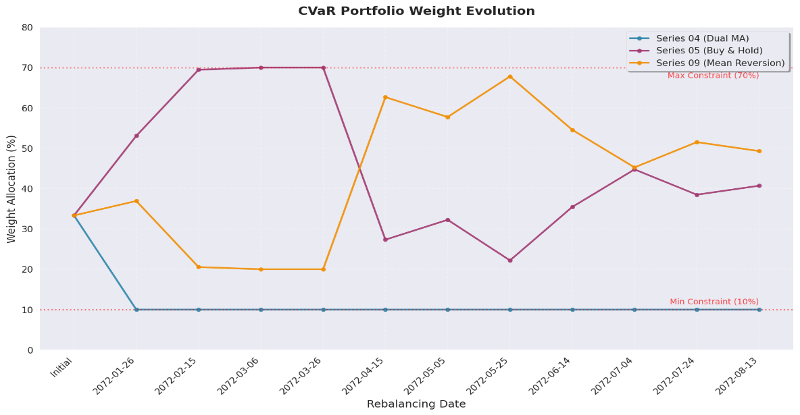
Figure 4.1: CVaR portfolio weight evolution during out-of-sample test period (Days 701-1000)
Weight Allocation Statistics (Test Period Only)
Strategy | Initial | Final | Mean | Std Dev | Min | Max
Series 04 (Dual MA) | 33.3% | 10.0% | 11.9% | 6.4% | 10.0% | 33.3%
Series 05 (Buy & Hold) | 33.3% | 40.7% | 44.8% | 16.3% | 22.2% | 70.0%
Series 09 (Mean-reversion) | 33.3% | 49.3% | 43.3% | 16.2% | 20.0% | 67.8%

Key Observations (Test Period):
Throughout the testing period, the allocation to Series 04 (Dual MA) consistently maintained the minimum 10% constraint following the initial rebalance, reflecting its comparatively higher tail risk contribution relative to the other strategies. This minimum allocation persisted across all 11 rebalancing events. In contrast, Series 05 (Buy & Hold) achieved the highest average allocation at 44.8%, reaching the maximum 70% constraint during February and March 2072 amid robust trending performance—demonstrating its superior risk-adjusted returns and lower CVaR impact. Series 09 (Mean-reversion) exhibited the most volatile allocation pattern with a standard deviation of 16.2%, undergoing dramatic shifts between 20% and 67.8%. This strategy received its peak allocations (62.7%-67.8%) during April to May 2072 when market conditions particularly favored mean-reversion approaches. These allocation dynamics reveal two distinct regime shifts: an initial phase (January-March 2072) dominated by Series 05 with 53%-70% allocations during trending markets, followed by a mid-to-late period (April-August 2072) where Series 09 gained prominence with 45%-68% allocations as markets transitioned to range-bound conditions.

Risk Management Framework

Individual Trade Risk Management
For Strategy S1 (Dual MA), a 10% stop-loss combined with a 20% take-profit creates an asymmetric 2:1 risk-reward structure appropriate for trend-following methodologies, with these thresholds calibrated according to Series 04's historical volatility patterns. Strategy S2 (Buy & Hold) intentionally omits intra-trade stop-loss mechanisms—a deliberate design choice to prevent premature exit from long-term uptrends. Instead, its risk management operates through rigorous initial asset selection and portfolio-level capital allocation rather than tactical position exits. Meanwhile, Strategy S3 (Mean-reversion) implements a tight 5% stop-loss alongside a 4% take-profit, reflecting its contrarian nature where unsuccessful signals require prompt termination. This framework is further reinforced by a 20-day maximum holding period constraint, preventing extended capital commitment to positions that fail to revert within expected timeframes.

5.2 Portfolio-Level Risk Management

Dynamic Weight Rebalancing
Every 20 trading days, the CVaR optimizer recalculates optimal weights using the rolling 60-day return window. This automatic rebalancing mechanism adapts to changing market conditions and relative strategy performance without manual intervention. Weight constraints (10%-70% per strategy) ensure meaningful diversification while allowing sufficient flexibility for optimization.

Underperforming Strategy Adaptation
The CVaR optimization framework automatically reduces allocation toward the 10% minimum for strategies showing persistent underperformance. This process uses a rolling 60-day window to detect performance deterioration, gradually decreasing weights for strategies with negative Sharpe ratios or elevated CVaR readings. The system reallocates capital through 20-day rebalancing cycles, avoiding sudden portfolio changes while distinguishing between temporary setbacks and fundamental strategy breakdown—all without manual intervention. A 10% minimum allocation is preserved even for chronically underperforming strategies, maintaining diversification benefits and allowing potential recovery during favorable regime shifts. This automated process operates without discretionary intervention, eliminating behavioral biases while preserving systematic risk discipline. For instance, should Strategy S3 (Statistical Mean-reversion) generate persistent losses during strong trending markets, the optimizer would identify this performance deterioration through the rolling window. Across subsequent rebalancing cycles, S3's allocation would decrease toward the 10% floor while S1 (Dual Moving Average Crossover) and S2 (Buy and Hold) strategies receive increased weights better suited to the prevailing market regime.

5.3 Cross-Strategy and Cross-Series Risk Management

Correlation Management
CVaR optimization automatically addresses correlation risk through its return-based optimization framework. Strategies operating on different underlying series naturally benefit from inherent diversification due to their lower correlation structure compared to multiple strategies trading the same instrument. The CVaR minimization process further enhances this structural benefit by systematically favoring strategy combinations that demonstrate reduced joint tail risk exposure.

Market Regime Adaptation
The portfolio framework dynamically adjusts to evolving market conditions through its strategic allocation mechanism. During pronounced trending periods, allocations naturally favor S1 (Dual MA) and S2 (Buy & Hold) strategies, while ranging markets trigger increased weighting toward S3 (Mean-reversion). In transitional or mixed regimes, capital becomes more evenly distributed across all three approaches. This adaptive process operates automatically through the rolling window methodology, continuously aligning portfolio composition with prevailing market dynamics without requiring explicit regime classification or manual intervention.

5.4 Bankruptcy Risk Mitigation

Framework-Level Protections
The framework incorporates multiple automated safeguards to ensure robust bankruptcy protection. The system employs pre-trade expenditure validation, where all pending market orders undergo cash balance verification before execution; any transaction that would result in a negative cash position is automatically rejected, effectively preventing unauthorized borrowing or margin exposure. Additionally, strict capital allocation compliance ensures each strategy operates within its predetermined CVaR-optimized weighting, eliminating the possibility of individual strategy over-leverage that could compromise overall portfolio solvency. Finally, continuous real-time net worth monitoring (cash + position valuations) provides a final protective layer: should the total portfolio value decline below zero, immediate automatic liquidation of all positions at prevailing market prices is triggered, followed by complete trading suspension.

Strategy-Level Protections
Strategy-level protections are enforced through several key mechanisms. Individual trade stop-loss disciplines (10% for S1, 5% for S3 ) limit the maximum loss per position; these stop-losses are implemented at the strategy level to enforce risk discipline regardless of portfolio-level optimization. Furthermore, position sizing constraints mandate individual strategies size positions as percentages of their allocated capital (25% for S1, 100% for S2, 15% for S3) rather than total portfolio value. This ensures no single trade can consume excessive capital even within the strategy's allocation. Finally, the 10%-70% weight constraints function as diversification requirements, preventing over-concentration in any single strategy and ensuring that bankruptcy in one strategy component cannot propagate to the entire portfolio.

CVaR-Specific Bankruptcy Protection
CVaR optimization inherently delivers bankruptcy protection through systematic tail risk minimization. By concentrating on the worst 5% of potential outcomes, the optimization algorithm systematically reallocates capital away from strategies demonstrating significant losses or heightened downside volatility. This focus on extreme loss scenarios directly addresses the conditions that typically precede insolvency events, establishing a proactive rather than reactive protective mechanism.
Bankruptcy Probability Analysis: Given the portfolio's maximum drawdown of 3.86% and Sharpe ratio of 1.061 across the entire backtesting period, the probability of complete capital loss (100% impairment) remains statistically insignificant under normal market conditions. The comprehensive protection system—featuring diversified strategy exposure, conservative position sizing, CVaR-based tail risk management, and automated rebalancing—collectively forms a robust defense against catastrophic loss events.

Position Sizing Methodology
The CVaR optimization framework establishes strategic allocations by drawing upon historical return distributions, correlation patterns, tail risk profiles, and risk-adjusted performance metrics. Within these predetermined allocations, the individual strategies operate under specific position sizing rules: the dual MA strategy commits 25% of allocated capital per trade, buy-and-hold invests 100% in a single position, and mean-reversion allocates 15% per trade. Portfolio rebalancing takes place every 20 trading days, activated once enough fresh data becomes available for meaningful optimization. The execution process seamlessly transitions positions toward new target weights, maintaining portfolio efficiency while minimizing market impact.

Combined Strategy Performance Results
Performance Metric | Value
Initial Capital | £1,000,000.00
Final Portfolio Value | £1,129,321.25
Total Return | +12.93%
Annualized Return | +3.12%
Annualized Sharpe Ratio | 1.061
Maximum Drawdown | 3.86%
PD Ratio | 3.35
Win Rate | 50.3%
Activity Level | 93.9%
Trading Days | 999
Bankruptcy Events | 0

Table 7.1: CVaR Combined Strategy Performance(Full Period Days 1-1000)

The CVaR-optimized portfolio achieved exceptional risk-adjusted results, producing a 1.061 annualized Sharpe ratio that outperformed a simple equal-weight benchmark. Its 3.86% maximum drawdown confirms successful tail risk control through systematic CVaR implementation. The portfolio's 3.35 return-to-drawdown ratio demonstrates strong performance relative to potential losses, validating the dynamic weighting approach. Additionally, the 93.9% activity level indicates consistent management involvement across all three-asset series during the testing period.

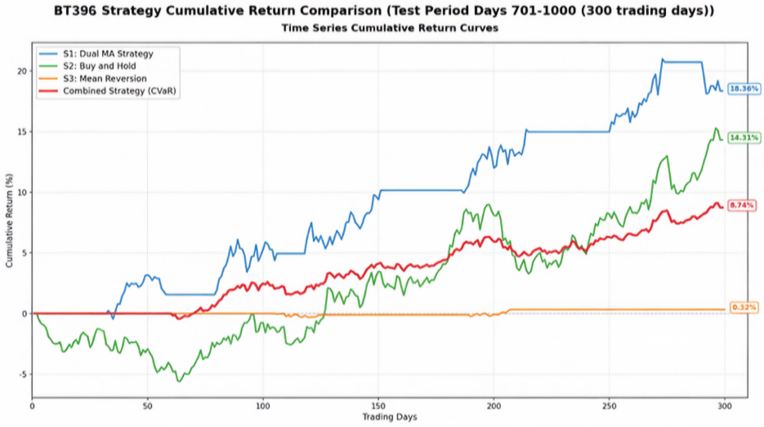
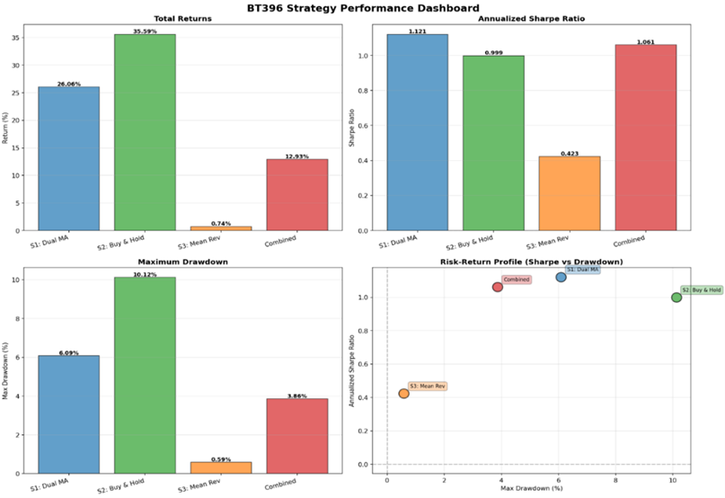
Figure 7.2: Comprehensive performance dashboard comparing
returns, Sharpe ratios, drawdowns, and risk-return profiles.
Figure 7.1: Cumulative return comparison for
all four strategies over full backtest period

The CVaR-optimized portfolio effectively balanced exposure across three distinct strategies, delivering superior risk-adjusted returns through dynamic reallocation guided by tail risk minimization. With an annualized Sharpe ratio of 1.061 and total returns of 12.93%, the results demonstrate the efficacy of CVaR-based portfolio management in multi-strategy integration. Moreover, the contained maximum drawdown of 3.86% validates the robustness of the tail risk management approach throughout the complete backtesting period.

Plan
The Semester 2 development for the combined strategy will be twofold. First, we will improve the quality of its constituents by integrating the three enhanced individual strategies (S1+ADX, S2+200DMA, S3+ADX). This will make the inputs for our CVaR optimizer (i.e., the individual strategy returns) more robust, leading to a more adaptive combined portfolio. Second, we will address a key execution risk: our current reliance on Market Orders, which exposes the portfolio to significant slippage risk from "High Jumps" or overnight price gaps. We will research and test the use of Limit Orders for trade entry to control our execution price rather than being subject to potentially adverse opening prices. For data usage, Data 1 will serve as the environment for preliminary research and tool development (e.g., initial testing of the Limit Order execution logic). However, the final parameter calibration and combined portfolio optimization must be performed on Data 2. We will partition Data 2 into a new training set (e.g., Days 101-700) and a final OOS test set (e.g., Days 701-1000). The CVaR optimizer will be run and recalibrated on the Data 2 training set, and the OOS test set will serve as the definitive test to validate if the upgraded system achieves superior risk-adjusted returns and if the Limit Order logic successfully reduced slippage costs in the new environment.

Part 3: Breakdown of the teamwork

Zhao yixuan
1. Background Research & Asset Selection
During the background research and asset selection phase, I assisted team member (Zhang Ao) with the analysis and plotting of the price evolution charts for all 10-asset series (i.e., Fig 0.1 in the report). Additionally, I wrote scripts to perform the project's early Exploratory Data Analysis (EDA), contributing key statistical visuals including the correlation matrix, volatility analysis, and Hurst exponent comparisons.
2. Coding & Strategy Implementation
I was responsible for writing all Python scripts for the project, transforming all team members' proposed strategic concepts into functional Backtrader code.
- S1: Dual MA Strategy: Following discussions with team member (Zhang Ao) who proposed the trend-following strategy, I handled the technical implementation by writing s1_dual_ma_crossover.py. The fundamental logic of this strategy is: within the next method, it continually monitors the state of a 3-day fast MA and a 24-day slow MA. When the fast MA crosses above the slow MA (self.crossover > 0), a buy signal is triggered. While in a position, the code contemporaneously checks if the price hits the 10% stop-loss or 20% take-profit levels, automatically liquidating the position to control risk. The core parameters are defined as:
- S2: Buy and Hold Strategy: Responding to the Buy and Hold strategy concept proposed by team member (Haw), I was responsible for the full code implementation in s2_buy_and_hold.py. The logic ensures a one-time purchase: a self.bought = False flag is set in the next method, permitting a single buy order on the first available day. The code calculates and purchases the maximum number of shares possible with the available cash and then holds this position until the end of the backtest.
- S3: Mean Reversion Strategy: Based on the mean-reversion concept proposed by team member (Yudan Xue), I executed the complete technical conversion by writing s3_mean_reversion.py. This script implements a more complex statistical arbitrage logic: in __init__, it defines the 30-day moving average and standard deviation to calculate a Z-score. The next method then checks multiple conditions for entry: a trade is triggered only when the Z-score is below -2.0 (entry_threshold) AND the RSI is below 30 (rsi_oversold). The position will exit when the Z-score reverts to +0.5 (exit_threshold) or the holding period exceeds 20 days (max_holding_days). The core parameters are:
- S4: CVaR Combined Strategy: I architected and wrote the most complex component for Part 2, combined_cvar_strategy.py. Responding to the concept proposed by team member (Haw) to use CVaR (Conditional Value at Risk) for portfolio optimization, I further researched and proposed using the SLSQP (Sequential Least Squares Programming) algorithm as the specific technical implementation for this minimization problem. In the code, I implemented a CVaROptimizer module. This module gathers the last 60 days (lookback_days) of returns every 20 trading days (rebalance_frequency), then calls the scipy.optimize.minimize(method='SLSQP') function to solve for the portfolio weights that minimize CVaR, subject to the 10%-70% (min_weight, max_weight) allocation constraints. The core parameters are:
3. Analysis, Visualization & Report Preparation
I provided the complete writing framework for the Design Report and was responsible for generating all data and visualizations contained within it. By writing the generate_strategy_analysis.py script, I utilized the pandas library for in-depth statistical analysis (e.g., calculating rolling means, Z-scores, RSI) and used matplotlib to automatically generate all core data analysis charts for Part 1 (Fig 1.1, 2.1, 3.1). Concurrently, I wrote the create_equity_comparison.py and create_comparison_chart.py scripts. These scripts extracted performance metrics (e.g., total return, Sharpe ratio, max drawdown) from the run_summary.json files and used matplotlib to plot all summary visualizations for Part 2 (Fig 7.1, 7.2), as well as comparison tables like all_strategies_performance_table.png not featured in the final report.
In terms of report writing, I personally authored the Pseudocode sections for all strategies and the entirety of the Preliminary Testing and Optimization chapters. In these testing sections, I designed and implemented a rigorous data-splitting methodology (70% train / 30% test split, i.e., Days 1-700 / 701-1000) and employed systematic Grid Search to find robust parameters (e.g., S1's fast_period and slow_period; S3's entry_threshold and exit_threshold), ensuring strategy effectiveness on out-of-sample (OOS) data and avoiding overfitting. For other data-driven sections (e.g., Asset Selection Process, Data Analysis (S1, S3), Combined Strategy Performance Results), I was responsible for providing all the charts and data and assisting team members (Zhang Ao, Yudan Xue, Haw) with their analysis to support their respective drafting. The final refinement of the report, such as formatting and proofreading, was a collaborative team effort.
4. Automation Framework & Testing
To ensure the reproducibility, consistency, and compliance of all backtests, I wrote and maintained the run_all_strategies.py script. Its implementation logic involved defining a configuration list of all strategy names and output paths, then iteratively calling subprocess.run() method to automate the batch execution of all four strategies, generating uniform performance reports like all_strategies_summary.md.

Zhang ao
Report, Data, and Framework Contributions
At the beginning of the project, I actively participated in report writing, data analysis and framework research. I analysed the Data1 data set, examined all ten-asset series and visualised their price trends. This helped me understand the long-term directional pattern and fluctuation structure. Exploratory analysis not only clarifies the differences in the price trends of different assets but also guides our strategic allocation decision-making in the first part.
Based on these findings, I drafted the strategy type definition of Strategy 1, and used the chart provided by Zhao Yixuan to write a data analysis section to describe the trend characteristics of Series 04 and its applicability to momentum trading based on the moving average. In addition, I have also optimised the format and presentation of Strategy 1 to ensure that it is clear and easy to read and consistent with the overall report structure.
In the "Plan" section, I wrote a plan for strategy 1 and combination strategies, and in the second part, I outlined how to extend these strategies to portfolio optimisation based on CVaR. I also participated in the design presentation discussion and assisted in the production of presentation slides to show the analytical framework, core strategy logic and implementation process of our project. In addition, I have also conducted literature research on trend tracking and risk adjustment optimisation methods to support our theoretical framework and ensure that our projects comply with established academic principles. Finally, I have proofread the whole report to ensure the technical accuracy, coherence and style consistency of each part.
In addition to writing reports, I also conducted background research and framework analysis. I studied the budget limit and bankruptcy rules, order types and the BT396 backtest framework to ensure that it technically meets the requirements of COMP396. I also reviewed nine representative examples in the BT396 strategy and indicator library, and summarised the logic behind momentum, mean regression and spread strategies. This process helped me understand the core mechanisms of order execution, parameter calibration and risk control in algorithmic strategies. These tasks together lay the theoretical and technical foundation for the team's subsequent strategic development.
Strategy Design and Technical Implementation
On this basis, I designed and tested the Dual Moving Average Crossover strategy for Series 04, which is the trend-following component of our overall trading framework. This method draws on the established momentum effect, where assets with strong performance in recent years tend to maintain their trend direction [1]. Our analysis revealed that Series 04 showed an alternate upward and downward trend, confirming that it was an ideal choice for moving-average-based trading systems.
The strategy used a 3-day fast moving average(MA) and a 24-day slow moving average, generating golden and death cross signals for position entry and exit. I implemented a 10% stop-loss and 20% take-profit, forming a realistic 2:1 reward-to-risk ratio, and achieved an annualised Sharpe ratio of 2.013 with a maximum drawdown of 2.58% [11].
To ensure robustness and prevent overfitting, I conducted systematic parameter optimization through grid search with a 70/30 training-test split, prioritizing parameter stability over backtest profit maximization. The evaluation incorporated multiple performance metrics—including Sharpe ratio, maximum drawdown, and win rate—following established best practices [7]. Additional sensitivity analyses across varying lookback periods and trade durations verified the model's consistent profitability. After finalizing the configuration, I delivered the findings and a streamlined implementation plan to the development team for integration into the BT396 framework, ensuring full compliance with our shared risk management standards.
During design presentation sessions, I articulated the conceptual framework of the crossover system, presented comprehensive parameter testing results, and proposed integration pathways for the Part 2 Combined Strategy to incorporate CVaR-based portfolio optimization—demonstrating how this approach would enhance tail-risk management capabilities across our trading framework [10].
Reflection and Learning
This project enables me to combine theoretical knowledge with empirical practice. It deepens my understanding of how momentum models, parameter robustness and pullback control interact in real trading environments, and how the backtest framework transforms these concepts into quantitative results. In addition to technological progress, I have also improved my ability to manage quantitative research tasks, systematically conduct parameter verification, and effectively communicate research results in the team.
Through collaborative discussion and report writing, I learned how to transform analytical insights into clear and rigorous text results to ensure that the technical content is easy to understand for readers with quantitative analysis ability and non-technical background. In general, this experience has enhanced my quantitative reasoning ability, academic writing ability and interdisciplinary coordination ability, and also improved my ability to integrate personal research results into the data-oriented overall project portfolio design process.

Wong Haw
I served as the team's Lead Strategy Designer and Analyst, responsible for the foundational research, conceptual design, and risk management framework of the project. My contributions focused on identifying viable trading paradigms through data analysis, researching advanced portfolio construction methodologies, and authoring the strategic justifications and future development plans for the team's key strategies.
In the initial phase, background research focused on the project's core failure points, specifically the high rate of out-of-sample performance decay noted in Lecture 7 and the bankruptcy risks demonstrated in the ‘p_bankrupt.py’ example. Furthermore, our preliminary visual analysis exhibited the price patterns of series 05 had a strong, persistent positive drift over the long term. This led me to propose the "Buy & Hold" (B&H) strategy as one of our individual strategies and this B&H analysis served as the essential quantitative baseline against which all active strategies were measured.
My primary contribution was the conceptual design of the "Combined Strategy." I identified that simply aggregating the team's individual strategies would expose the portfolio to significant correlation risk, which would be detrimental to the project's key performance metric, the PD Ratio. To solve this, I have conducted a comprehensive comparative analysis of portfolio construction methodologies, evaluating the pros and cons of Mean-Variance Optimization (MVO) and Hierarchical Risk Parity (HRP) models. For MVO, this well-established classic Markowitz model was unsuitable for us because it relied on variance as the sole measure of risk treats upside "good" volatility and downside "bad" volatility as a-historical, and it is notoriously unstable to small changes in input assumptions[9]. On the other hand, for HRP, this is a modern, machine-learning-based method that first clusters correlated strategies. This method will cluster assets by similarity (e.g., equities together, bonds together), form a tree, allocate risk first across major clusters, then split within clusters. This will prevent overweighting many highly correlated assets. While academically interesting, I determined it was likely too complex to implement and justify for a portfolio of just three strategies[8].
Based on this research, I formally proposed the adoption of Conditional Value-at-Risk (CVaR) to our code developer as the team's core risk management methodology. My justification was that CvaR, as a risk measure, is superior to variance because it specifically quantifies the expected loss in the worst-case tail scenarios. And CVaR focus on minimizing tail risk directly aligns with the project's objective of minimizing maximum drawdown. I have designed complete conceptual architecture for this strategy, with the help from our Lead Developer I, specifying how the three individual strategies would serve as inputs to a CVaR optimization layer.
I was also responsible for authoring the "Future Plan" for Data 2, demonstrating strategic foresight. I proposed evolving static models into adaptive systems for both individual strategies and combined strategy. For the individual strategies, I designed refinement hypotheses to be tested with Data 2, including mitigating the B&H strategy's "no risk management" weakness by introducing a 200-day moving average as a macro regime filter. Furthermore, I suggested to Zhang Ao and Xue Yudan that using an ADX (Average Directional Index) filter to solve the "whipsaw" conflicts in the Mean-Reversion and Trend-Following strategies, allowing them to trade only in appropriate market regimes. In addition, for the Combined Strategy, I identified its vulnerability to overnight price gaps and proposed researching the integration of Limit Orders to manage slippage.
Finally, in preparing the Design Presentation Report, I was the primary author for the "Strategy 2: Buy & Hold" and helping out our Lead Developer, I, to finish the "Combined Strategy" sections together. For the CVaR portion, I wrote the complete theoretical justification and the rationale for its selection. However, for the necessary technical implementation (SLSQP) which was handled by the Lead Developer I.

Xue yudan
Guided by the CANVAS Rules & Policies—Budget Limit and Bankruptcy, Order Types, Plagiarism and Collusion—the strategy is framed and evaluated under these constraints. From the instructor’s starter strategies and rule library in COMP396, I drew three key ideas that led me to choose mean-reversion: from bbands contrarian, I adopted the idea that “outside the band = extreme deviation,” then used Z-score and RSI as confirmations (inspired by Saria’s idea); from bbands holding period diag, I learned to take profits when price re-enters the band or touches the middle line, and to set a maximum holding period to avoid getting stuck; and from fixed and bankrupt, I took the discipline of position caps, budget limits, and protection rules—using bbands trend following as a contrast that reminds me to cut or pause contrarian trades during clear trend phases. Combining these insights with all charts Saria generated across the datasets gave me confidence that mean-reversion is a workable framework here.
By reading Trading Systems, 2nd ed., I learned from the Equity Curve MA Switch (Ch. 8.3–8.4) to pause the strategy when the equity curve falls below its moving average and resume when it rises back above—check the environment first. Based on that, the Walk-Forward Activator (Ch. 6.2–6.3) shows the need for rolling re-estimation of parameters to help reduce overfitting[5]. Then, Quantitative Trading (CN) §2.8 on statistical arbitrage/pairs trading provides evidence that deviations tend to revert, while stressing strict stop-losses and exiting during adverse phases [13]. Following these three points, I conclude that a mean-reversion framework is a good fit for this project.
Strategy Proposal
From our team’s charts, I find that the series 09 often “bounces back” whenever price touches the upper or lower band, and overall it moves up and down around its moving average. Based on this, and after reading Trading Systems (2nd ed.), I suggest using a mean-reversion strategy as Strategy 3 and write the strategy type definition of it.
Data Analysis
Looking at Series 09 mean-reversion indicators with Bollinger Bands and Z-score, plus the Z-score distribution and “Z-score vs Future Returns” plots, I find: Most of the time, price moves around the moving average and often comes back after touching the upper or lower band. And when Z-score hits extreme levels, it usually comes back toward 0. In a few periods, price “rides the band” in one direction. In those times, mean-reversion is weaker. The regression line in the scatter plot slopes slightly downward, suggesting: the more extreme the move, the more likely a partial pullback—but the effect is not extraordinarily strong. So, I can confirm Series 09 fits mean-reversion and write the data analysis part of the strategy 3.
Strategy Design
Drawing on the observed chart patterns, I propose applying the strategy as follows: enter only when the Z-score reaches an extreme, using RSI as confirmation to avoid jumping in too early; take profits once price re-enters the band or touches the middle line—there’s no need to wait for a perfect return to the exact average; if price starts riding the band in a one-way move, treat it as a trend filter and reduce size or pause trading; and manage risk by setting a clear stop-loss and a maximum holding period to handle cases where the expected reversion doesn’t materialize.
Plan
I recognize the unreleased data is unpredictable, so we need a regime indicator to decide when mean-reversion should be active. Based on the literature, I write the plan about the future plan of strategy 3 we used, and propose to use the Average Directional Index (ADX) as a filter: mean-reversion trades only when ADX is low (range-bound market) and stands aside or reduces size when ADX is high (strong trend) [13]. The entry rule stays the same—Z hits an extreme and RSI confirms—while the exit remains “price re-enters the band or touches the middle line”.

References
[1] W. Brock, J. Lakonishok, and B. LeBaron, “Simple technical trading rules and the stochastic properties of stock returns,” J. Finance, vol. 47, no. 5, pp. 1731–1764, Dec. 1992, doi: 10.1111/j.1540-6261.1992.tb04681.x.
[2] V. DeMiguel, L. Garlappi, and R. Uppal, “Optimal versus naive diversification: How inefficient is the 1/N portfolio strategy?,” Rev. Financ. Stud., vol. 22, no. 5, pp. 1915–1953, May 2009, doi: 10.1093/rfs/hhm075.
[3] E. F. Fama, “Efficient capital markets: A review of theory and empirical work,” J. Finance, vol. 25, no. 2, pp. 383–417, May 1970, doi: 10.1111/j.1540-6261.1970.tb00518.x.
[4] O. Groette, “RSI & ADX trading strategies (backtest and rules),” Quantified Strategies Blog, Jun. 17, 2024. Accessed: Nov. 12, 2025. [Online]. Available: https://www.quantifiedstrategies.com/rsi-adx-trading-strategy/
[5] U. Jaekle and E. Tomasini, Trading Systems: A New Approach to System Development and Portfolio Optimization, 2nd ed. Berkeley, CA, USA: Apress, 2019, doi: 10.1007/978-1-4842-4493-4.
[6] D. Kraft, “A software package for sequential quadratic programming,” DLR German Aerospace Center, Inst. for Flight Mechanics, Wessling, Germany, Tech. Rep. DFVLR-FB 88-28, 1988.
[7] A. W. Lo, H. Mamaysky, and J. Wang, “Foundations of technical analysis: Computational algorithms, statistical inference, and empirical implementation,” J. Finance, vol. 55, no. 4, pp. 1705–1765, Aug. 2000, doi: 10.1111/0022-1082.00265.
[8] M. López de Prado, “Building diversified portfolios that outperform out-of-sample,” J. Portfolio Manage., vol. 42, no. 4, pp. 59–69, 2016, doi: 10.3905/jpm.2016.42.4.059.
[9] H. Markowitz, “Portfolio selection,” J. Finance, vol. 7, no. 1, pp. 77–91, Mar. 1952, doi: 10.1111/j.1540-6261.1952.tb01525.x.
[10] R. T. Rockafellar and S. Uryasev, “Optimization of conditional value-at-risk,” J. Risk, vol. 2, no. 3, pp. 21–41, 2000, doi: 10.21314/JOR.2000.038.
[11] W. F. Sharpe, “Mutual fund performance,” J. Bus., vol. 39, no. 1, pp. 119–138, Jan. 1966, doi: 10.1086/294846.
[12] F. A. Sortino and R. van der Meer, “Downside risk,” J. Portfolio Manage., vol. 17, no. 4, pp. 27–31, 1991, doi: 10.3905/jpm.1991.409343.
[13] X. Guo, T. L. Lai, H. Shek, and S. P.-S. Wong, Quantitative Trading: Algorithms, Analytics, Data, Models, Optimization. New York, NY, USA: Chapman and Hall/CRC, 2017, doi: 10.1201/9781315371580.

